1. These tables can be related through the use of foreign keys. Specifically, the Assignments table can have a foreign key referencing the Teacher table, and the Students table can have a foreign key referencing the Assignments table. This creates a one-to-many relationship between teachers and assignments, and a many-to-many relationship between students and assignments. Here is a diagram of the database:

```

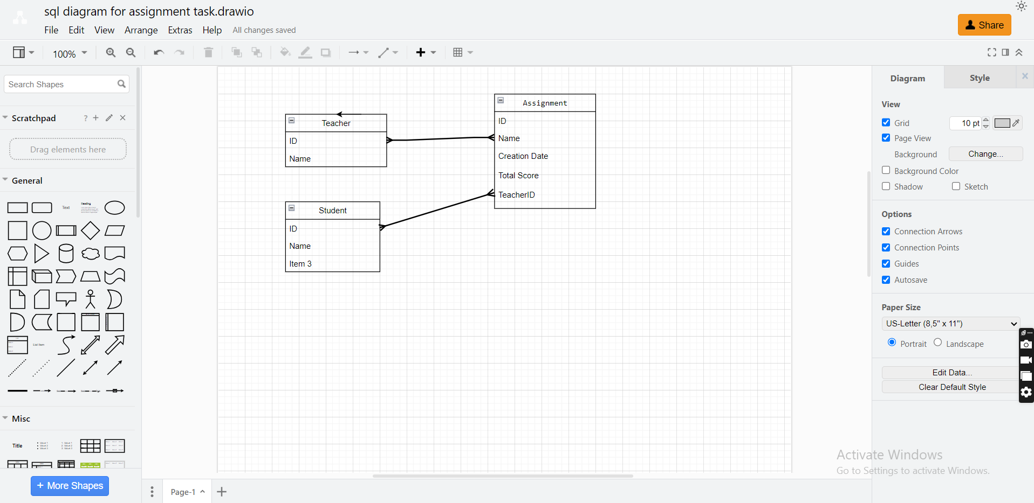

2. To retrieve all the teachers' names that created assignments on '21/6/2021', the following SQL statement can be used:

SELECT DISTINCT Teacher.Name

FROM Teacher

INNER JOIN Assignment ON Teacher.ID = Assignment.TeacherID

WHERE Assignment.[Creation Date] = '21/6/2021';

```

3. To retrieve all the teachers' names and the number of assignments created by each teacher, the following SQL statement can be used:

SELECT Teacher.Name, COUNT(Assignment.ID) AS 'Number of Assignments'

FROM Teacher

INNER JOIN Assignment ON Teacher.ID = Assignment.TeacherID

GROUP BY Teacher.Name;

```